Jon Janelle

MAT 500

10/15/2013

**Chapter 8 Exercises**

**(8.1 A&B)**

Let $θ_{1}$ be the proportion of successes after a successful shot and $θ_{2}$ be the number of successes after a failed shot. A Beta(30, 10) prior distribution is used for both parameters, which expresses the belief that 75% of attempts are made in either case.

Using the data that Larry Bird made 251 of 285 shots after a success and 48 of 53 shots after a failure, the following histogram of credible differences between $θ_{1}$ and $θ_{2}$ was generated. Since 0 lies within the 95% HDI, we conclude that a difference of zero between $θ_{1}$ and $θ_{2}$ is credible, and therefore there is insufficient evidence to support Larry Bird having a “hot hand.”

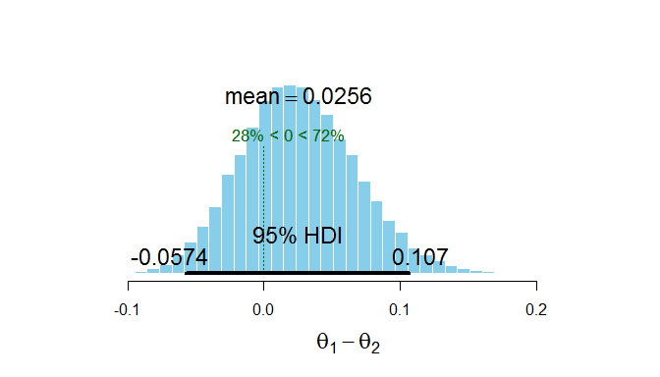

**8.4A)**

When $θ_{1}=0.005$ and $θ_{2}=0.005$, the probability that proposed jumps fall outside the acceptable range. Consequently, 97.8% of proposed values were accepted and the posterior is far more tightly clustered than that shown in Figure 8.3. The autocorrelation graphs for $θ_{1} and θ_{2}$ below also demonstrate that successive steps are strongly correlated with their predecessors, which is further evidence that a standard deviation of 0.005 is a poor choice.

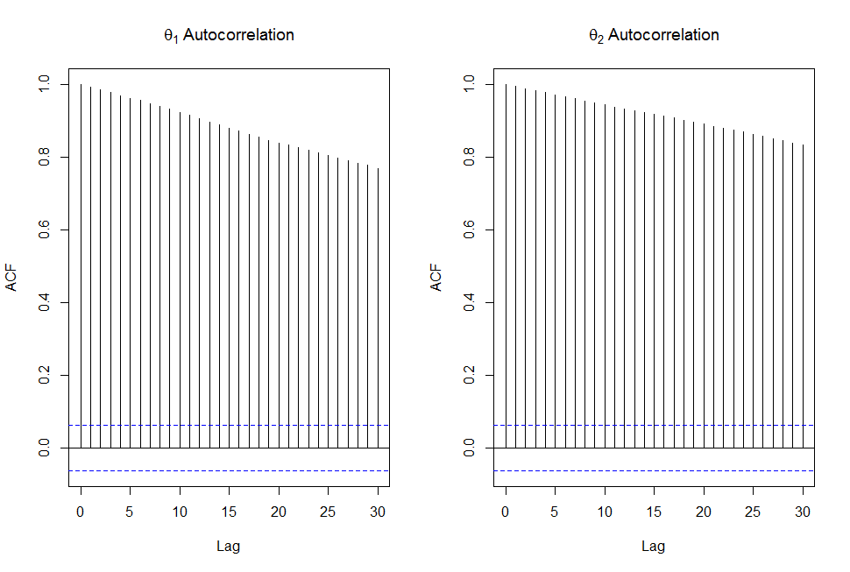

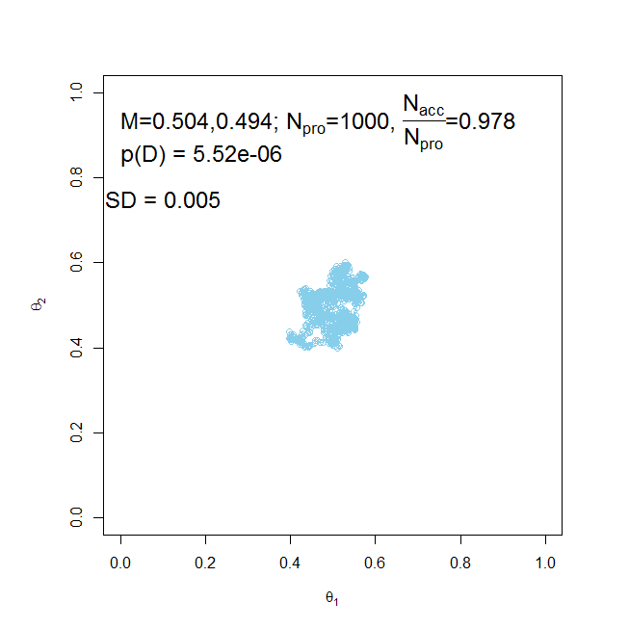

**8.4B)** If $θ_{1}=5.0$ and $θ_{2}=5.0$, then practically none of the proposed jumps are accepted. The large standard deviation results in nearly all of the proposed jumps falling outside of the posterior distribution’s probable range, and thus does not accurately represent the distribution. This is shown by the plot below in which only 0.1% of proposed jumps were accepted out of 1000 proposals.

